March 18th, 2007
Hi
Again, not that much to write about. Last Monday morning, I went to the clinic to have the biopsy on the patch of one side of the nose. Go again next week to get the result. Earlier that same morning, when I woke up, I was not feeling so good but could not figure out where or why. After the clinic visit, I felt worse and so went straight to bed. I did not eat any lunch or dinner. At about 7 pm, I vomited and later diarrhoea. I think it might have been food poisoning. Could have been the foods from China! It took several days to get back to feeling normal. Of course, no exercise on Monday.
On Tuesday, I was feeling a bit better so did some work - fortunately, it was not difficult work. Went to the gym later to see how I would do – did skipping 30 min (20+5+5) then a slower run. Had a small dinner. On Wednesday, I began exercise with 45 min non-stop skipping (with only 1 trip). This is the longest skip I have had and that 1 hour of skipping you talked about Gavin begins to look as if it could be possible for me. For the four-day gym week, I did 130 min skipping, but because that was equal to the time I did the previous (5-day) week, I did another 2.5 min just to beat that time.
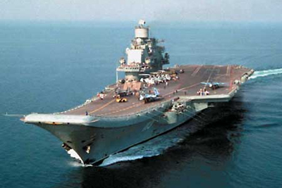
Yesterday, I went for another longer run, this time for about 3 hours in the Tai Mei Tuk/Bride’s pool area ending up at Luk Keng. The run was a few minutes slower than last year but OK. This was the first drizzly run for the season. That is OK, as I do mind rain though in some places it was slippery underfoot.
Across the bay from Luk Keng at Sha Tau Kok, the former Russian aircraft carrier, the “Minsk” is still anchored. Apparently, it has been closed down now as a tourist attraction and a report suggests that it could find its final resting place as an artificial reef in Hong Kong waters!

On Thursday evening, the two candidates for the Chief Executive election had the second their two ‘debates.’ This one was open to the public, who were chosen from those who applied to represent a good cross-section of the population. In reading last year’s letter, I wrote about the shoot-out between an off-duty policeman (killed) and two on-duty police officers (one killed). The inquiry into the deaths of the two is underway now.
That’s about it for now.

Cheers.

